

Autonomous Device for Obstacle Detection

By

170423: Ahtsham Alam

171456: Syed Ahmed Abdullah

Supervised By

Hafiz Dr. Ahmad Jalal

FYP – II (Report)

2019 - 2020

Date of Submission: Project ID: 1701

**FYP – II (Report) Mark Form**

**Scheme – 1: Software Project**

|  |  |  |
| --- | --- | --- |
| **To Be Filled By Students** | | |
|  | **Student 01** | **Student 02** |
| **Registration No** | 170423 | 171456 |
| **Student Names** | Ahtsham Alam | Syed Ahmed Abdullah |
| **Project Title** | Autonomous device for obstacle detection | |
| **Supervisor** | Hafiz Dr. Ahmed Jalal | |

|  |  |  |  |  |
| --- | --- | --- | --- | --- |
| **To Be Filled By Examiners** | | | | |
|  | | **Max** | **Student 01** | **Student 02** |
| **Project Poster** | |  |  | |
|  | Design | **10** |  | |
|  | Content | **5** |  | |
| **Project Management (Attendance)** | | **10** |  |  |
| **Presentation** | |  |  |  |
|  | Layout and Design | **5** |  |  |
|  | Delivery and Appearance | **5** |  |  |
|  | Content and Impact | **5** |  |  |
| **FYP – II Report** | |  |  |  |
|  | Analysis of Problem | **10** |  | |
|  | Use Cases | **10** |  | |
|  | Requirement Analysis | **10** |  | |
|  | Design of Solution | **10** |  | |
|  | Implementation of Solution | **10** |  | |
|  | Business Model | **10** |  | |
|  | **Total** | **100** |  |  |

|  |  |  |  |  |
| --- | --- | --- | --- | --- |
| **Feedback:** | | | | |
|  |  |  |  |  |
| **Supervisor** | **Session Chair** | **Moderator** |
|  |  |  |

Table of Contents

1. Introduction 4

1.1. Goals and Objectives 4

1.2. Scope 4

1.3. Major Constraints 4

2. Background 4

3. Use Cases(s) 4

3.1. Use Case Diagram 4

3.2. Use Case Description 4

4. Specific Requirements 5

4.1. Functionality 5

4.2. Non-Functional Requirements 5

5. User Interfaces 6

6. Business Model 6

6.1. Value Proposition 6

6.2. Minimum Viable Product 6

6.3. Customer Segments 6

6.4. Distribution Channels 6

7. Project Gantt chart 6

8. Bibliography 6

# Introduction

# This is the Smart city project that will be based on Artificial Intelligence, Image Processing and some touch of Hardware (Robotics). We make autonomous device that moving and taking decision on its own intelligence. The things done so far is that the device can detect the obstacle and take decision and move to the side where distance is greater than the provided max distance.

## Goals and Objectives

Our fundamental goal is to facilitate the people so for this purpose our project objectives is to make a device autonomous and this autonomous device has an ability to taking decisions on its own and also an ability to detect the obstacles on its way. By making the device autonomous is itself a big achievement but if we can detect obstacles and recognize the obstacle as well then imagine how many goals, we can achieve through this like real world settings in different fields such as military, medical field, space exploration and everyday housekeeping etc.

Our main objectives are following:

**Beneficial thing for the people:** Less human responsibilities, Machine Vision, so that there are less chances of human errors.

**Autonomous Device:** Device moving and turning by taking decision on its own intelligence.

**Obstacle Detection:** Detection of the obstacles is possible while device moving or static.

**Obstacle Recognition:** Able to recognize specific type of obstacles.

**Voice based Movement:** Device able to move on the basis of voice.

## Scope

Basically, the scope of the Autonomous device for obstacle detection is to make a device autonomous and this autonomous device has an ability to taking decisions on its own and also an ability to detect the obstacles on its way. Furthermore, the device is able to control through voice and also able to recognize the obstacles. For voice it using the Voice module, Bluetooth and for objects recognition it’s using Camera and Data set to learn. Things that we done so far to achieve that scope are given below. we are defining our goals, task, deadlines, cost on the basis of the things we have achieved.

**1.2.1 Goals:**

* **Make device Autonomous.** No human interaction the device can move autonomously.
* **Detecting the Object.**  Device itself detecting the obstacle.
* **Taking Decision** Device itself taking the decision and control itself.

**1.2.2 Tasks:**

* Study related Projects
* Buy Equipment’s
* Learning Arduino IDE
* Learning other sensors and motor module connectivity.
* Discuss with supervisor
* Designing stage
* Developing stage
* Make device autonomous
* Device detecting obstacles
* Device taking decision.
  + 1. **Deadlines:**

|  |  |
| --- | --- |
| Task | Deadlines |
| Study Related Projects | 15th august to 30th august |
| Buy Equipment’s | 1st September to 10th September |
| Learning Arduino IDE | 11th September to 28th September |
| Learning other sensors and motor module Connectivity | 1st October to 10th October |
| Discussion with supervisor | After every 15 days. |
| Designing stage | 11th October to 30th October |
| Developing Stage | 1st November to 14th November |
| Make device Autonomous | 17th November to 20th November |
| Device Detecting Obstacles | 14th November to 30th November |
| Device Taking Decision | 1st December to 10th December |

**1.2.4 Cost:**

Cost structure may include the following:

* Components cost
* Travelling Cost
* Manufacturing Cost
* Maintenance Cost
  + 1. **Deliverables:**

Deliverable may include:

* Device with All Objectives and features
* Backend source code of Arduino
* Mobile Application (optional)

## Major Constraints

There are some major constraints for proper execution of our project.

**No abnormal Path:**

There no chance for the device to complete working on the path like sandy, slippery.

**Descent Weather:**

Not working in the rain as well as in a stormy weather. Basically, device requires normal weather like sunny or cloudy because their equipment’s may affect.

**Budget:**

Budget is one of the major constraints that lemmatize our Project objectives because the more you have the budget the more you buy the more powerful equipment’s that can help to achieve more objectives.

**Battery and components compatibility:**

In the field like robotics components compatibility is one of the major constraints because if you connect wrong input and output to the component’s then they going to be dead and you have to buy the new ones ☺.

# Background

Previously there are many autonomous devices build for obstacle detection purpose (Ms. D.D Jadhav 2016), (Kolapo Sulaimon Alli 2018) and (Pandit 2020) But the problem is that their behavior is not rational and the accuracy is not much efficient because it maximizes the computational time. That’s why device stuck in the loop sometimes and not take the required decision on time that can affect the working. So, what we are doing is to make the computational time as less as we can by following the rational behavior so that the accuracy and decision on time performance increases. Furthermore, our device is able to control through voice and able to recognize the obstacles.

# Use Cases(s)

## Use Case Diagram

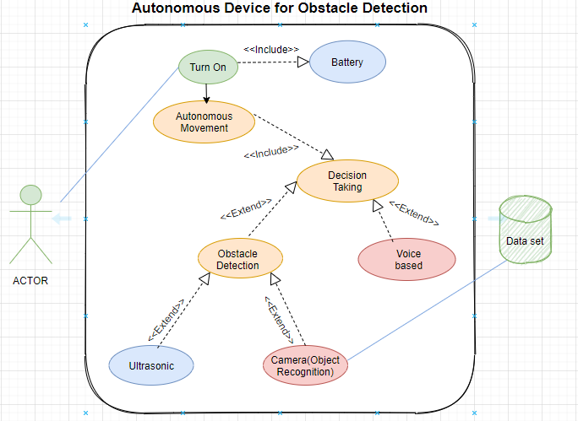

## Use Case Description

[Create a use case description for all use cases using following template.]

|  |  |
| --- | --- |
| **Use Case ID:** | UC-01 |
| **Use Case Name:** | Autonomous movement |
| **Actors:** | Device |
| **Description:** | Device can move autonomously |
| **Trigger:** | Device can move when receiving voltage from the motor. |
| **Preconditions:** | There must be proper wiring, battery connectivity, Arduino and motor module must present. |
| **Post conditions:** | Sensor must be connected for obstacle detection |
| **Normal Flow:** | Arduino give signal to motor module that can move tire automatically. |
| **Alternative Flows:** | Nothing |
| **Exceptions:** | Battery low, decision problem |
| **Includes:** | Decision use case |
| **Assumptions:** | Nothing |
| **Notes and Issues:** | Wire connectivity issues |

|  |  |
| --- | --- |
| **Use Case ID:** | UC-02 |
| **Use Case Name:** | Turn On |
| **Actors:** | Human/ User |
| **Description:** | To on the device |
| **Trigger:** | When user change direction of button |
| **Preconditions:** | Proper connectivity of button with the device battery Vcc. |
| **Post conditions:** | - |
| **Normal Flow:** | Turn On the button and then current flows in the device then device movement occurs |
| **Alternative Flows:** | Nothing |
| **Exceptions:** | Device not move |
| **Includes:** | Battery |
| **Assumptions:** | Nothing |
| **Notes and Issues:** | Button is not working |

|  |  |
| --- | --- |
| **Use Case ID:** | UC-03 |
| **Use Case Name:** | Decision Taking |
| **Actors:** | Device |
| **Description:** | Machine can understand the environment |
| **Trigger:** | When device starts. |
| **Preconditions:** | There must be proper connections of sensors and other components. |
| **Post conditions:** | Obstacle availability and Object recognition connectivity. |
| **Normal Flow:** | Take reading from the environment then give information to the motor module to move the tire. |
| **Alternative Flows:** | Voice based Decision |
| **Exceptions:** | Logical issues occur |
| **Includes:** | Arduino, and other sensing components. |
| **Assumptions:** |  |
| **Notes and Issues:** | Arduino and motor module sometimes dead. |

|  |  |
| --- | --- |
| **Use Case ID:** | UC-04 |
| **Use Case Name:** | Obstacle Detection |
| **Actors:** | Sensors |
| **Description:** | Detect Obstacle so that it Avoid obstacle from hitting with the device. |
| **Trigger:** | Whenever obstacle reach specific distance to the device |
| **Preconditions:** | There must be proper configuration of sensor with the device. |
| **Post conditions:** | Obstacle availability and Recognition configuration. |
| **Normal Flow:** | When sensor reach the specific distance to obstacle then it can detect |
| **Alternative Flows:** |  |
| **Exceptions:** | Not timely detection. |
| **Includes:** | Ultrasonic (in our case) |
| **Assumptions:** |  |
| **Notes and Issues:** | Sensor dead. |

|  |  |
| --- | --- |
| **Use Case ID:** | UC-05 |
| **Use Case Name:** | Voice Based |
| **Actors:** | Device |
| **Description:** | Move Autonomously on the basis of voice |
| **Trigger:** | When listen the specific key words of voice |
| **Preconditions:** | Proper Voice Equipment Configuration |
| **Post conditions:** | Proper Predefined Voice instructions and its configurations. |
| **Normal Flow:** | When listen the specific key words of voice the device moves on that direction. |
| **Alternative Flows:** |  |
| **Exceptions:** | Device not respond after hearing the voice |
| **Includes:** | Bluetooth, Voice Module. |
| **Assumptions:** |  |
| **Notes and Issues:** | Response late, Half keyword detect. |

|  |  |
| --- | --- |
| **Use Case ID:** | UC-06 |
| **Use Case Name:** | Camera (Object Recognition) |
| **Actors:** | Device |
| **Description:** | Compare the Obstacle image with pre feeded image in dataset and display object name. |
| **Trigger:** | When find the obstacle then its trigger. |
| **Preconditions:** | Proper Camera Configuration, Image data set. |
| **Post conditions:** | Proper Shapes of the objects must be visible and make sure the objects must be those that are defined in the data set. |
| **Normal Flow:** | When detect obstacle Compare the Obstacle image with pre feeded image in dataset and display object name. |
| **Alternative Flows:** |  |
| **Exceptions:** | Image of the obstacle that are not in dataset |
| **Includes:** |  |
| **Assumptions:** |  |
| **Notes and Issues:** | Sometimes not capture the proper obstacles so that’s why camera not recognize that obstacle. |

|  |  |
| --- | --- |
| **Use Case ID:** | UC-07 |
| **Use Case Name:** | Ultrasonic |
| **Actors:** | Device |
| **Description:** | Detect the distance of obstacle by receiving the sending sound waves. |
| **Trigger:** | Send signal for object |
| **Preconditions:** | Proper wiring and other ultrasonic required Components configuration. |
| **Post conditions:** | Make sure Reflect-able objects Not waves absorbable object. |
| **Normal Flow:** | Sending sound waves that reflects from the obstacle and then calculate the distance. |
| **Alternative Flows:** |  |
| **Exceptions:** | Not timely receive the sending waves. |
| **Includes:** |  |
| **Assumptions:** |  |
| **Notes and Issues:** | Due to different Obstacles shapes some time sending waves not received. |

# Specific Requirements

Specific Requirements includes Functional and Non-Functional Requirements of the project.

## Functionality

The Functional Requirements of our Project are: -

|  |  |
| --- | --- |
| Identifier | FR-01 |
| Title | Autonomous Movement |
| Requirement | Arduino, motor module |
| Source | Supply of current by turning on the button. |
| Rationale | Obstacle Detection |
| Restrictions and Risk | Dead risk |
| Dependencies | Battery |
| Priority |  |

|  |  |
| --- | --- |
| Identifier | FR-02 |
| Title | Obstacle Detection |
| Requirement | Sensors, Camera |
| Source | Environment |
| Rationale | Receiving the sending waves after reflected by the obstacle. |
| Restrictions and Risk | waves absorb obstacles |
| Dependencies | Obstacle must available |
| Priority |  |

|  |  |
| --- | --- |
| Identifier | FR-03 |
| Title | Distance between Device and Obstacle |
| Requirement | Ultrasonic sensor |
| Source | Mathematical Formulas |
| Rationale | Time taken by the sound waves to reach the receiving end and divided by 2. |
| Restrictions and Risk | Waves not received |
| Dependencies | Arduino, battery |
| Priority |  |

|  |  |
| --- | --- |
| Identifier | FR-04 |
| Title | Decision Taking |
| Requirement | Arduino, Voice module, |
| Source | Signals Receiving from the Arduino. |
| Rationale | Distance measurement |
| Restrictions and Risk | Wrong or late decisions |
| Dependencies | ultrasonic sensor, Bluetooth |
| Priority |  |

## Non-Functional Requirements

The core feature of the device is to make it autonomous and obstacle detection, but it will certainly have more features given below that are worth mentioning.

|  |  |
| --- | --- |
| Identifier | FR-01 |
| Title | Obstacle Recognition |
| Requirement | Camera, Dataset |

|  |  |
| --- | --- |
| Identifier | FR-02 |
| Title | Voice based Movement |
| Requirement | Voice recognition Module, Bluetooth Module |

|  |  |
| --- | --- |
| Identifier | FR-03 |
| Title | Verifying Pin |
| Requirement | Keypad |

|  |  |
| --- | --- |
| Identifier | FR-04 |
| Title | Night Vision (Optional) |
| Requirement | Night vision sensors. |

# User Interfaces

Autonomous Device for Obstacle detection is a Hardware based Project So this is basically an interface that show to the user. 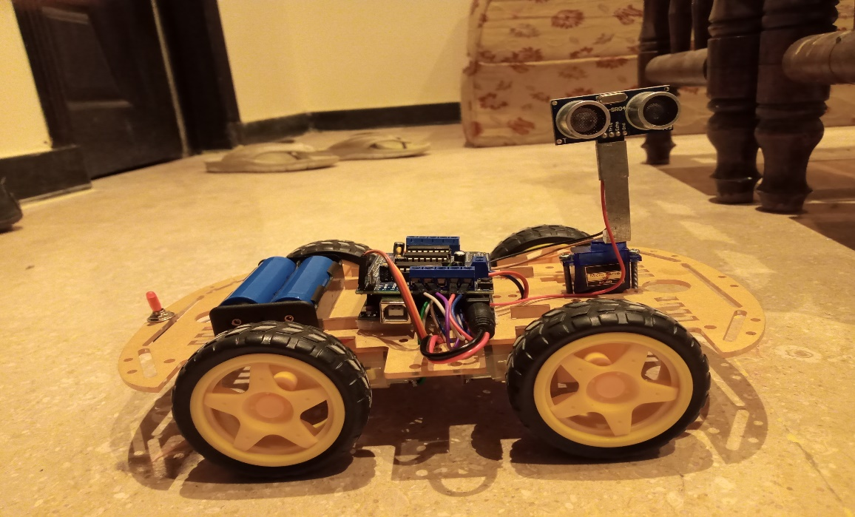

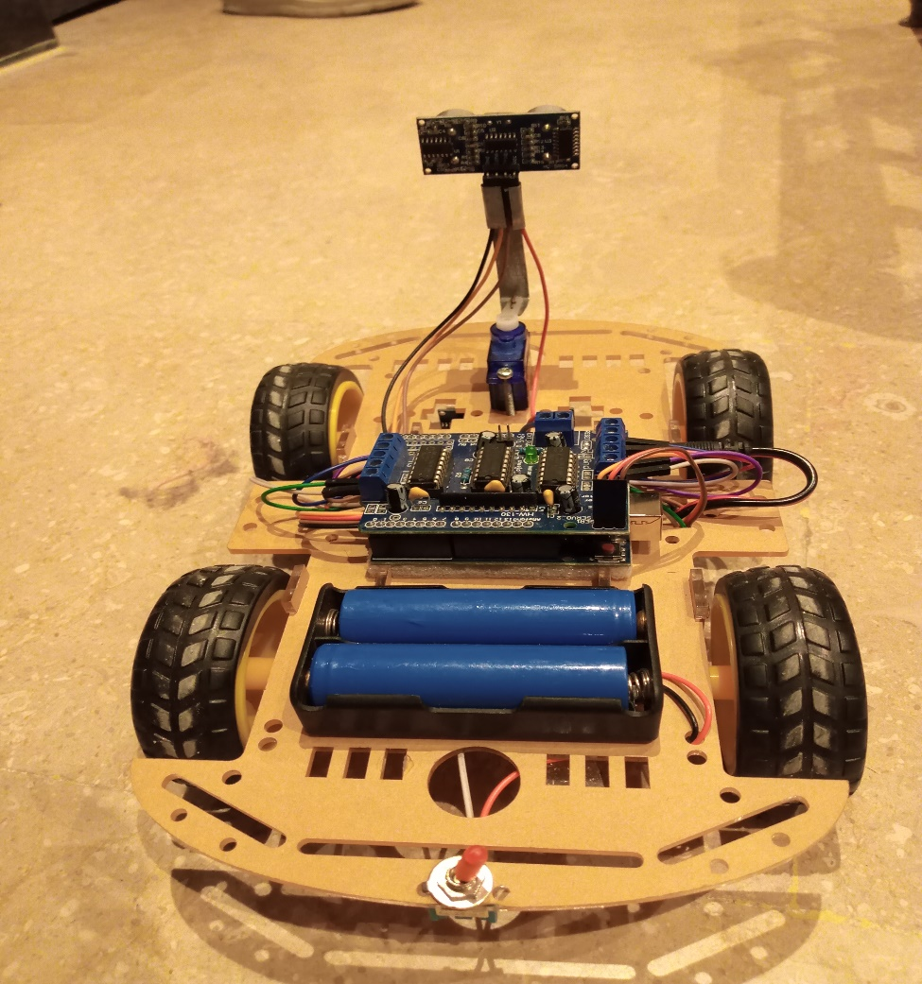

# Business Model

# Project Gantt chart

**Group Member:**

Ahtsham Alam

Ahmed Abdullah

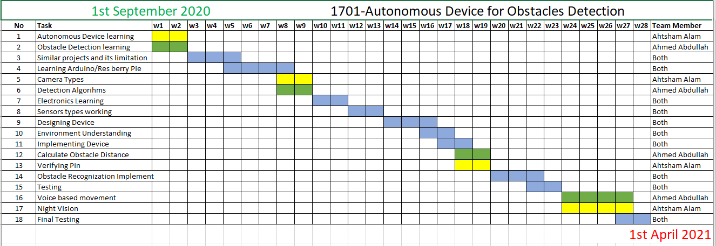

**7.1**

**Gantt Chart of the task we achieved so far is given below**

|  |  |  |  |  |  |  |  |  |  |  |  |  |  |  |  |  |  |  |  |
| --- | --- | --- | --- | --- | --- | --- | --- | --- | --- | --- | --- | --- | --- | --- | --- | --- | --- | --- | --- |
| Autonomous Device for Obstacle Detection | | | | | | | | | | | | | | | |  |  |  | Member |
| Up to December Months | | | | | | | | | | | | | | | |  |  |  |  |
|  | Tasks | w1 | w2 | w3 | w4 | w5 | w6 | w7 | w8 | w9 | w10 | | w11 | w12 | | w13 | w14 | w15 |  |
| 1 | Study Related Projects |  | |  | | | |  | | |  | | |  | |  |  |  | Both |
| 2 | Buy Equipment’s |  | |  |  | | |  | | |  | | |  | |  |  |  | Ahtsham |
| 3 | Learning Arduino IDE |  | | |  | | |  | | |  | | |  | |  |  |  | Ahmed |
| 4 | Learning other sensors and motor module Connectivity |  | | |  | |  |  | | |  | | |  | |  |  |  | Both |
| 5 | Designing stage |  | | |  | | |  | | |  | | |  | |  |  |  | Ahtsham |
| 6 | Developing Stage |  | | |  | | |  | | | |  | |  | |  |  |  | Ahmed |
| 7 | Make device Autonomous |  | | |  | | |  | | | | | | |  |  |  |  | Both |
| 8 | Device Detecting Obstacles |  | | |  | | |  | | | | |  | | |  |  |  | Both |
| 9 | Device Taking Decision |  | | |  | | |  | | | | |  | | |  |  |  | Both |

# Bibliography

Gijs Dubbelman, Wannes van der Mark, Johan C. van den Heuvel, Frans C.A. Groen. 2007. "Obstacle Detection during Day and Night Conditions using Stereo Vision,." *Intelligent Robots and Systems,* Page 5 and 6.

This paper proposes different statistical methods to find the distance using stereo vision techniques. The strength of this paper is that it’s a practical approach that using in many robotics and real time car manufacturing companies because stereo vision can find distance and path allocation in Day as well as night. We Chose this paper for our research because in future its very helpful to related to our Project when we do obstacle detection on basis of camera and also helps in our night vision feature.

Hind Laghmara, Mohamed-Taha Boudali, Thomas Laurain, Jonathan Ledy, Rodolfo Orjuela, Jean-Philippe Lauffenburger and Michel Basset. 2019. "Obstacle Avoidance, Path Planning and Control for Autonomous Vehicles." *Université de Haute-Alsace, France.* Page 3,4,5,.

This paper proposes three different levels to reach autonomous vehicles. The strength of this paper is that grid-based approach is used for obstacle detection. smooth and control obstacle avoidance trajectory is generated which helps to reach an accurate result. We Chose this paper for our research because it’s very helpful to related to our obstacle detection functionality but this approach is very costly.

Kolapo Sulaimon Alli, Moses Oluwafemi Onibonoje, Akinola S. Oluwole, Michael Adegoke Ogunlade, Anthony C. Mmonyi, Oladimeji Ayamolowo and Samuel Olushola Dada. 2018. "DEVELOPMENT OF AN ARDUINO-BASED OBSTACLE AVOIDANCE ROBOTIC SYSTEM FOR AN UNMANNED VEHICLE." *ARPN Journal of Engineering and Applied Sciences* Volume 3.

In this paper the system consists of two (Infrared and Ultrasonic) sensors, an Arduino microcontroller and a gear DC motor. The ultrasonic and infrared sensors are implemented to detect obstacles on the robot's path by sending signals to an interfaced microcontroller. The micro-controller redirects the robot to move in an alternate direction. The main strength of this paper is that Its a less costly approach through which we can achieve maximum result.

Mario Hirz, Bernhard Walzel. 2018. "Sensor and object recognition technologies for self-driving car." *Computer-Aided Design & Applications, Graz University of Technology,* Page 3 and 4.

This paper proposes different levels of automated driving functions according to the SAE standard and derives requirements on sensor technologies. Subsequently, state of the art technologies for object detection and identification as well as systems under development are introduced, discussed and evaluated in view of their suitability for automotive application. It using LADAR approach which is very costly.

Ms. D.D Jadhav, Komal Jadhav, Kajal Shinde, Anjali Sonawane. 2016. "Autonomous Vehicle with Obstacle Avoidance and Tracking." *International Journal for Research in Applied Science & Engineering Technology (IJRASET)* 4.

In this paper a driverless vehicle that has an onboard GPS module which is capable of driving the vehicle from one point to another without human operator. Arduino the micro-controller redirects the robot to move in an alternate direction. The main strength of this paper is that it is low cost, and has high ranging capabilities approach through which we can achieve maximum result.

Pandit, Abhiemanyu. 2020. "Obstacle Avoiding Robot using Arduino and Ultrasonic sensor." *Circuit Digest*, May 20.

This is basically a link that shows to how to manufacture the autonomous device for obstacle detection. Complete working of the components, Problems of connectivity, limitations and every thing that we need to develop the device are in this.

Remenan., Surya. 2019. "Beginners Guide to Object Detection Algorithms." *Analytics Vidhya*, April 28.

This is basically a link that helps to learn three main type of obstacle recognition algorithms techniques that based on machine vision.